Final Project Report

ShopAI: AI-based Online Shopping
with Product Recommendations

Submitted By
Name: Faizan Ahmad

EXORDIUM

In the name of Allah, the Compassionate, the Merciful.

Praise be to Allah, Lord of Creation,
The Compassionate, the Merciful,
King of Judgment-day!

You alone we worship, and to You alone we pray for help,
Guide us to the straight path

The path of those who You have favored,

Not of those who have incurred Your wrath,
Nor of those who have gone astray.

PREFACE
In today's digital era, online shopping has become a significant part of our lives. However, finding the right products among the multitude of choices available online isn't always easy. This project aims to make online shopping more personalized by using smart technology to help users discover products that suit their preferences.
This project started because we wanted to improve the online shopping experience. We're using a clever system that looks at how people shop and suggests items they might like based on their previous choices. It's like having a helpful assistant who knows your taste in clothes and suggests things you'd probably enjoy.
Our main objectives are simple: firstly, we aim to use machine learning techniques to understand what people like and recommend products they're likely to purchase. Secondly, we want to show how using data and technology can make online shopping more enjoyable and effortless for everyone.
I am grateful to those who provided this ecommerce fashion data on Kaggle. This data has been instrumental in helping us study and comprehend how people shop for clothes online.
As you go through this project, we hope it sheds light on how technology and understanding user preferences can significantly enhance the online shopping experience.

Name: [Faizan Ahmad]
TABLE OF CONTENTS

CHAPTER NO. 1
gathering & Analyzing info 9

1.1 Introduction

1.2 purpose

1.3 scope

1.4 definitions, acronyms and abbreviations

1.5 Project requirements

1.5.1 Functional Requirements

1.5.2 Non-Functional Requirements

1.6 use cases and usage scenarios

1.6.1 Use Case Diagrams

1.6.2 Usage Scenarios

1.7 Development Methodology

1.7.1 Chosen Methodology

1.7.2 Reasons for Chosen Methodology
1.7.2 Work Plan (Gantt Chart)
1.7.2 Project Schedule (Submission Calendar)

CHAPTER NO. 2
designing the project 30

2.1 Introduction

2.2 purpose

2.3 scope

2.4 definitions, acronyms and abbreviations

2.5 Architectural Representation (Architecture Diagram)

2.6 Dynamic Model: Sequence Diagrams

2.7 Object Model/Logical Model: Class Diagram

2.8 Database Model (Database Diagram)

2.9 Graphical User Interfaces

Chapter no.3
DEvelopment 48
3.1 Development plan (Architecture Diagram)

CHAPTER 1
Gathering & Analyzing Info

1.1 Introduction
In an increasingly digital world, the Shop-AI project aspires to redefine the landscape of online shopping. It aims to achieve this by introducing an AI-driven platform that delivers custom-made product recommendations, thereby elevating the overall shopping experience for users. Through the utilization of sophisticated content-based filtering methods, the system can precisely analyze user preferences and behaviors, resulting in precise and personalized product suggestions.
The project aims to introduce an innovative solution that not only simplifies the process of product exploration but also increases user engagement, thereby making substantial contributions to the domain of e-commerce and enhancing customer satisfaction in the digital age.

1.2 purpose
The primary purpose of the Shop-AI project is to establish a groundbreaking platform that not only aligns with to users' preferences but also enhances their overall satisfaction and convenience during online shopping endeavors. By utilizing cutting-edge AI technologies, the platform aims to simplify the process of finding products and ensure that users can find products that best resonate with their unique tastes and requirements.

1.3 scope
The Shop-AI project's impact goes beyond individual users, aiming to revolutionize the online shopping experience for the entire community. With access to the comprehensive E-commerce Fashion Dataset from Kaggle, the platform can retrieve key product information like brand, details, selling prices, and categories. By incorporating these essential data points, Shop-AI can deliver personalized recommendations, distinguishing it from other existing solutions.
Moreover, Shop-AI's commitment to community enhancement is evident in its ability to create an informed and interactive online shopping environment. By providing users with precise and relevant guidance, the platform not only facilitates efficient decision-making but also reduces the chances of dissatisfaction with purchases. This develops a sense of trust among consumers, contributing to the growth and sustainability of online businesses and the e-commerce industry.

1.4 definitions, acronyms and abbreviations
- AI: Artificial Intelligence
- Kaggle: It is a data science competition platform and online community of data scientists and machine learning practitioners under Google LLC.
- E-commerce: electronic commerce, the buying and selling of goods and services over the internet
- Dataset: a collection of data, often presented in a structured format for analysis
- Content-based filtering: It uses item features to recommend other items similar to what the user likes, based on their previous actions or explicit feedback.

1.5 Project requirements
1.5.1 Functional Requirements
- User Management: The system should allow users to create an account and manage their personal details. The admin should also be able to manage user accounts.
- Product Catalog: The system should provide a comprehensive product catalog. Users should be able to search for products by keywords and filter the results based on categories, brands, price range, etc.
- Shopping Cart and Checkout Process: Users should be able to add products to their shopping cart, view it, and make changes to the quantity or remove products. The checkout process should guide users through the payment and shipping information, including the selection of a payment method and entering billing and shipping details.
- Order Management and Tracking: The admin should have the ability to manage orders, including viewing and updating order information.
- Customer Support: The system should have a customer support system for users to contact the store.
- Product Recommendations: The system should generate personalized product recommendations based on user preferences and item attributes.
- Guest Checkout: Guests should be able to enter their billing and shipping details and complete the purchase without having to register an account.

1.5.2 Non-Functional Requirements
- Performance: The system will employ efficient algorithms and optimize infrastructure to handle a large number of concurrent users, ensuring real-time product recommendations within acceptable response times.
- Usability: The system will feature an intuitive interface with clear navigation, informative product descriptions, and a visually appealing design, enhancing the overall shopping experience and ease of use.
- Reliability: The system will be highly reliable, ensuring minimal downtime, effective error handling, and proper mechanisms to prevent data loss.
- Availability: The project will strive to maintain high system availability, minimizing planned maintenance windows and implementing fault-tolerant mechanisms to handle unexpected failures.
- Accessibility: The system will be designed to be accessible to all users, including those with disabilities. It will work well with assistive technologies and have features that make it easier for users with disabilities to navigate and use the system.
- Compatibility: The system will be compatible with a wide range of devices, browsers, and operating systems, allowing users to access the platform from various platforms and ensuring a seamless experience.
- Data Privacy: The system will comply with relevant data protection regulations, including user consent for data processing, anonymization of sensitive information, and appropriate access controls to safeguard user privacy.
- Documentation: The project will provide comprehensive documentation, including user manuals and technical guides, to assist users and future developers in understanding and maintaining the system effectively.

1.6 use cases and usage scenarios
1.6.1 Use Case Diagrams

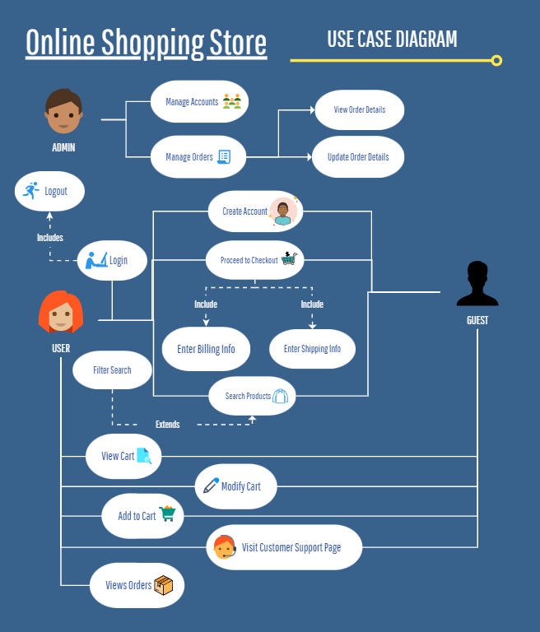

1.6.2 Usage Scenarios

Use-case title | Create Account
Abbreviated title | CRT_ACC
Use-case ID | UC1
Description | Users register, providing necessary information for account creation. The system validates and generates a unique user account for system access.
Pre-conditions | - User does not have an existing account.  - The required information for account creation, including name, email, phone number, address and password etc. is provided by the user.
Task Sequence | - User selects "Register" option.  - User provides required information.  - System validates information.  - Account is created.
Exceptions | - Invalid/ missing input  - Existing Account  - Network Connectivity Failure
Post-conditions | - Account created and stored in the database.  - The system displays account creation message and changes page from register to login.  - User can now login using the credentials.
Author | FAIZAN AHMAD

Use-case title | Login
Abbreviated title | LOGIN
Use-case ID | UC2
Description | User logs in to the website by providing his/her account credentials. The system validates credentials from the database, authenticates the user and takes user to home page.
Pre-conditions | - User has an existing account.  - The credentials provided are correct.
Task Sequence | - User clicks on the "Login" option.  - User enters credentials in login form.  - System validates the information  - User is logged in.
Exceptions | - Invalid/ missing input  - Network Connectivity Failure
Post-conditions | User is logged in.  The system displays login successful message and changes page from login to either homepage or last redirected page.  If any items were present in guest cart, they are moved cart associated with user id.  Users can logout by clicking on logout button.
Author | FAIZAN AHMAD

Use-case title | Search Products
Abbreviated title | SRCH_PROC
Use-case ID | UC3
Description | User searches for products based on keywords. The system shows relevant products.
Pre-conditions | - Product catalog is available.  - System is functional and accessible.
Task Sequence | - User enters keyword in search box.  - System processes search query and displays relevant product results.  - User looks at products shown and can choose to look at their details by clicking on them.
Exceptions | - Invalid keyword.  - Network connectivity failure.
Post-conditions | - The search results are displayed  - The user can view the details of the products.  - The user can proceed with adding products to cart and then to the checkout process.
Author | FAIZAN AHMAD

Use-case title | Filter Products
Abbreviated title | FLTR_PROC
Use-case ID | UC4
Description | Users apply filters to narrow down product search results based on specific criteria. The system processes the filter options selected and updates the displayed product list.
Pre-conditions | - The product catalog is available & updated.  - The product catalog contains products that can be filtered based on the criteria.
Task Sequence | - User selects filter options.  - System processes selected filters.  - System shows product list.  - User views filtered products list.
Exceptions | - Invalid filters.  - No results found.  - Network connectivity issues.
Post-conditions | - Filtered products list is displayed.  - User can view the filtered products list and also then proceed with buying process.
Author | FAIZAN AHMAD

Use-case title | Add Product to Cart
Abbreviated title | ADD_TO_CART
Use-case ID | UC5
Description | User adds a selected product to their shopping cart for future purchase. The system updates the cart contents and redirects user to the cart page.
Pre-conditions | - User is at the product detail page.  - The product is available for purchase.
Task Sequence | - User selects a product.  - User adds the product to the cart.  - System updates the cart.  - User is directed to the cart page.
Exceptions | - If sizes are present and user doesn’t select an option from select size.  - Network issues.
Post-conditions | - Cart is updated with the added product.  - User is directed to the cart page.
Author | FAIZAN AHMAD

Use-case title | View Cart
Abbreviated title | DSPLY_CRT
Use-case ID | UC6
Description | Users can access and review the contents of their shopping cart, including product details, quantity, and prices, before proceeding to checkout.
Pre-conditions | - The user has added product(s) to the cart.  - The user is either logged in or is accessing the cart as guest.
Task Sequence | - User opens the shopping cart.  - System displays the cart contents.  - User reviews the items in the cart.  - User proceeds to checkout or continues shopping.
Exceptions | - Empty Cart  - Network connectivity issues.
Post-conditions | - The user can proceed with the buying process.  - The user can modify the quantity or remove items from the cart.  - The user can view the total cost of the items in cart.
Author | FAIZAN AHMAD

Use-case title | Modify Cart
Abbreviated title | MDFY_CRT
Use-case ID | UC7
Description | The user modifies the contents of their shopping cart by adding or removing products. The system updates the cart accordingly, reflecting the changes made.
Pre-conditions | - The user has an existing shopping cart.
Task Sequence | - User views the cart.  - User adds or removes products from cart.  - System updates the cart accordingly.  - User verifies the cart and proceeds with further actions.
Exceptions | - Empty Cart  - Network connectivity issues.
Post-conditions | - The cart is updated with the modifications made.  - The user can proceed with further actions.
Author | FAIZAN AHMAD

Use-case title | Proceed to Checkout
Abbreviated title | PRCD_CHKOUT
Use-case ID | UC8
Description | User proceeds to the checkout process to finalize their purchase by entering payment and shipping information.
Pre-conditions | - User has one or more products in the cart.  - User is logged in or is using a guest account.
Task Sequence | - User confirms cart details and proceeds.  - User selects "Checkout" option.  - System presents "Enter Shipping Information" page (<<include>> relationship).  - User fills the form.  - System confirms this information and proceeds.  - System presents "Billing Page" to the user (<<include>> relationship).  - User clicks PayPal or Debit/Credit button.  - User enters his/her details.  - System confirms payment and shows order successful page.
Exceptions | - Invalid payment information.  - Missing shipping information.  - Network connectivity issues.
Post-conditions | - Payment and shipping information is securely stored for order processing.  - System confirms payment and shows order successful page.
Author | FAIZAN AHMAD

Use-case title | View Orders
Abbreviated title | ORD_HISTORY
Use-case ID | UC9
Description | If a user is logged in, he/ she can view order history. It shows order details like order number, order status, amount paid and date of order creation etc.
Pre-conditions | - User is logged in.  - User has ordered something in the past.
Task Sequence | - User clicks "Orders" in the navbar.  - System presents my orders page.  - User can view order details in the table.  - User can also click on order to view more details.
Exceptions | - User is not logged in.  - No order history.
Post-conditions | - System shows my orders page to the user.
Author | FAIZAN AHMAD

Use-case title | Customer Support
Abbreviated title | CUST_SUP
Use-case ID | UC10
Description | User clicks on customer support in the footer section of website. The user can see contact details like email and phone number. He/ she can also directly click on Instagram id given to be directed to Instagram account and contact from there with his/ her queries.
Pre-conditions | - User is logged in or using the system as a guest.  - User requires assistance or has inquiries related to the system or products.
Task Sequence | - User clicks "Customer Support."  - System presents customer support page.  - User chooses preferred method.  - User contacts using email, phone number or from Instagram and provides details of the issue or inquiry.  - The team resolves user’s issue.
Exceptions | - Technical issues preventing from contacting customer support.  - Delay in response due to high volume.
Post-conditions | - When contacted, user receives a response from customer support team.
Author | FAIZAN AHMAD

Use-case title | Manage User Accounts
Abbreviated title | MNG_USR_AC
Use-case ID | UC11
Description | The admin has access to users’ information and the ability to manage user accounts in the online shopping store.
Pre-conditions | - Admin has permission to access the system.  - User account information is available.
Task Sequence | - Admin selects Account model.  - Admin chooses to create a new account or edit an existing account.  - If creating a new account, admin enters required details.  - If editing an existing account, admin selects and modifies user details.  - Admin saves changes or new account creation.
Exceptions | - Account already exists for account creation.  - Invalid or incomplete user account information.  - Error in updating or deleting user accounts.
Post-conditions | - User account information is successfully created, edited, or deleted as per the admin's actions.
Author | FAIZAN AHMAD

Use-case title | Manage Orders
Abbreviated title | MNG_ORD
Use-case ID | UC12
Description | This use case involves the management of orders by the admin. The admin is responsible for performing actions related to viewing and updating order details.
Pre-conditions | - Admin has access to the system.  - There are existing orders in the system.
Task Sequence | - The admin selects the "Order" option from Orders Model.  - The system retrieves a list of existing orders.  - The admin chooses a specific order to view or update.  - If viewing order details, the system displays the order details & the admin reviews these order details.  - If updating order details, the system provides options to modify various aspects of the order & the admin makes the necessary changes to the order details.  - The admin saves the changes made to the order.  - The system updates the order information accordingly.
Exceptions | - No existing orders.  - Error in retrieving or updating order details.
Post-conditions | - System records the changes in order history.  - Admin can continue managing other orders or choose to exit.
Author | FAIZAN AHMAD

1.7 development methodology
1.7.1 Chosen Methodology
There are various software development lifecycle models.
Here are a few well-known of them:
- Waterfall Model
- Spiral Model
- V-Model
- RAD (Rapid Application Development) Model
- Incremental Model etc.
For this project, we will use VU Process Model.
The VU Process Model is a hybrid software development approach that combines the sequential nature of the waterfall model with the iterative and feedback-driven elements of the spiral model. It offers a structured yet flexible framework for efficient and effective software development.
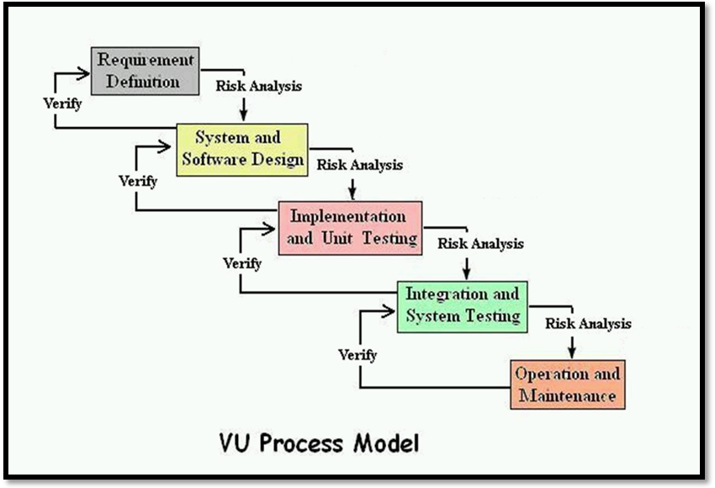
Figure 1.0

Waterfall Model:
The waterfall model is a sequential software development approach where each phase is completed before moving to the next. It follows a structured and linear process, making it suitable for projects with stable and well-understood requirements.
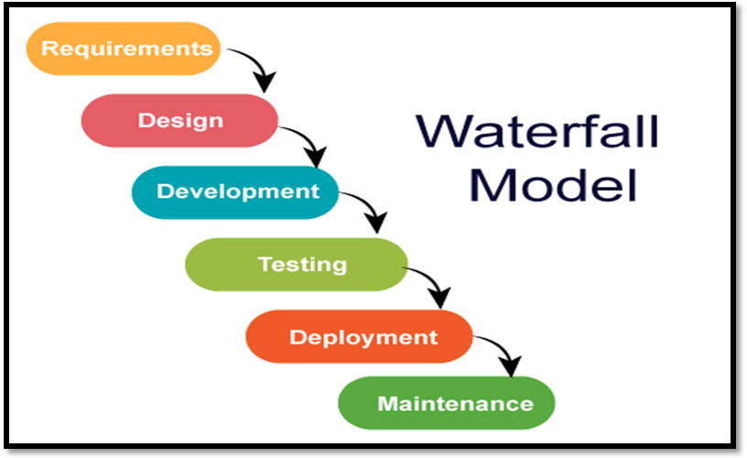
Figure 2.0

Spiral Model:
The spiral model is an iterative and risk-driven software development approach. It combines elements of the waterfall model with iterative development and risk analysis. It accommodates changing requirements and emphasizes continuous risk management throughout the project lifecycle.
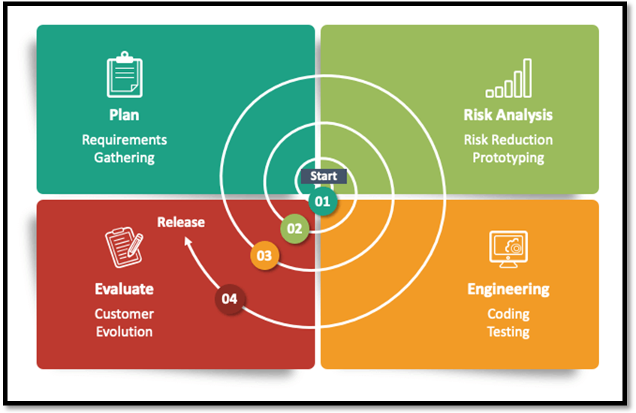
Figure 3.0

1.7.2 Reasons for Chosen Methodology
- Flexibility: VU Process Model combines waterfall and iterative approaches, allowing for adjustments and iterations based on changing requirements.
- Risk Management: VU Process Model emphasizes risk analysis and management at each phase, addressing potential risks associated with user preferences and product recommendations.
- Scalability: VU Process Model can handle large datasets and complex algorithms, accommodating the analysis of user behavior at scale.
- Comprehensive Solution: VU Process Model integrates key phases like requirements gathering, user modeling, similarity analysis, and recommendation generation for a holistic development approach.

1.7.2 Work Plan (Gantt Chart)
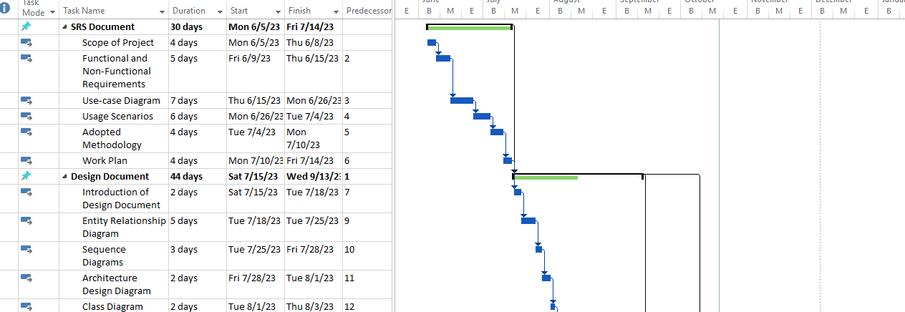
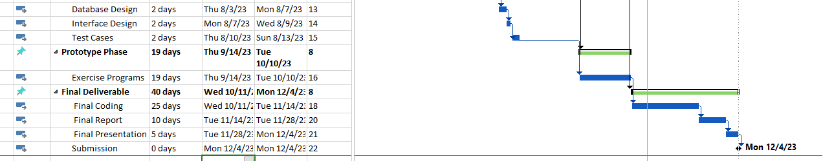

1.7.2 Project Schedule (Submission Calendar)
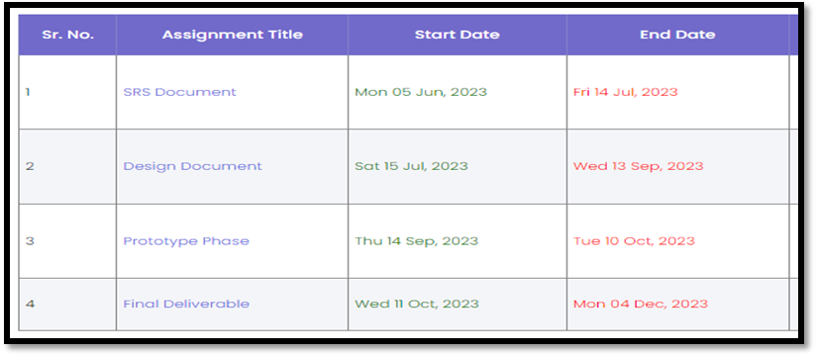

CHAPTER 2
Designing the Project

2.1 Introduction
Design document of SHOP-AI project presents a comprehensive plan for the development of an AI-based online shopping platform that will make recommendations of products with higher chances of getting sales.
Importance & Benefits of the Designing the Project:
Clarity and Alignment: It provides a common understanding of how the software will work, ensuring that everyone involved in the project is on the same page.
Risk Reduction: By identifying potential issues early, it helps avoid costly problems during development.
Efficiency: It guides developers, making development faster and more efficient.
Quality Assurance: It's essential for testing and quality control, ensuring that the software works as intended.
Future-Proofing: A well-designed system can adapt to future changes and enhancements.

It allows us to create reusable and modular code, making the development and integration easier. It also minimizes the risk of errors and delays during development. We can also ensure a much fast and reliable system by identifying and solving design problems beforehand. Lastly, the designing the project serves as a valuable reference for future maintenance, ensuring smooth updates and modifications.

2.2 purpose
It is a critical component of the software development process. Its’ main purpose is to formally document the design of software. It serves as a blueprint that outlines the architectural and structural aspects of the system. This document plays a vital role in ensuring the successful execution of the project, and its significance cannot be overstated.

2.3 scope
The scope of this design document encompasses all essential design aspects, including:
- Entity Relationship Diagram (ERD)
- Sequence Diagram
- Architecture Design Diagram
- Class Diagrams
- Database Design
- Interface Design, and
- Test Cases
Through the integration of these components, it delineates the specific functionalities and structural elements that will form the foundation of the ShopAI platform.

2.4 definitions, acronyms and abbreviations
- AI: Artificial Intelligence
- QA: Quality Assurance
- ERD: Entity Relationship Diagram
- Blueprint: a design plan or other technical drawing.
- Comprehensive: Including with all or nearly all aspects of something

2.5 Architectural Representation (Architecture Diagram)
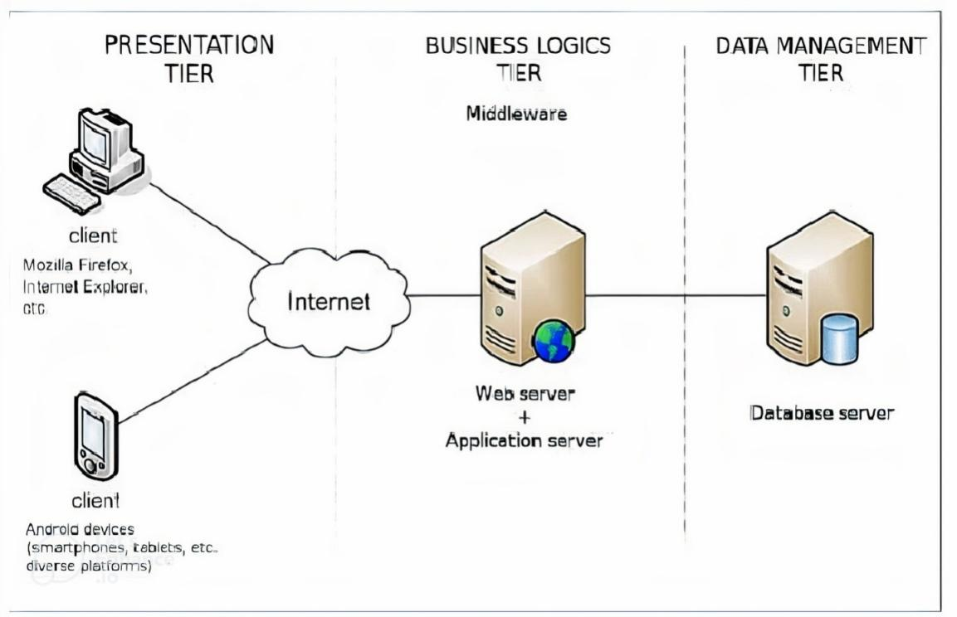

2.6 Dynamic Model: Sequence Diagrams

User Accounts Management:
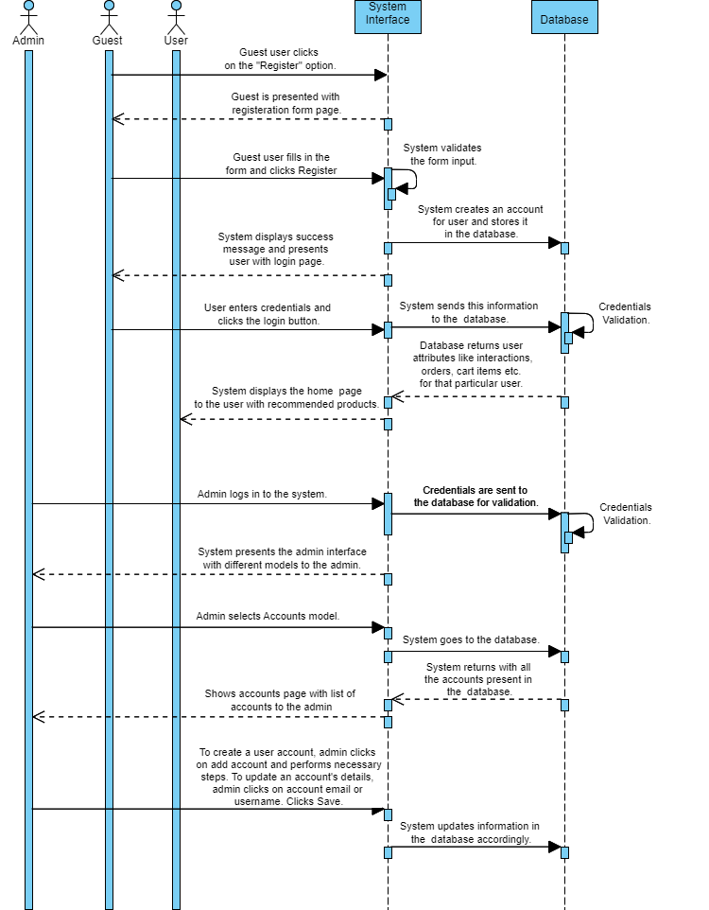

Product Catalog Interaction:
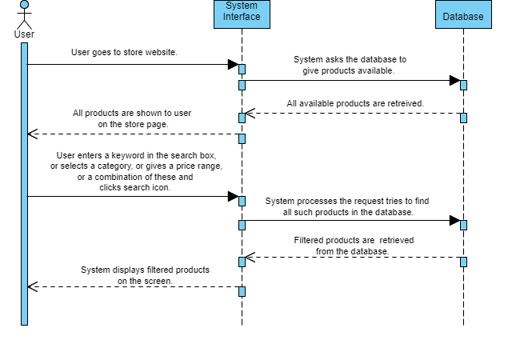

Cart Management and Checkout Process:
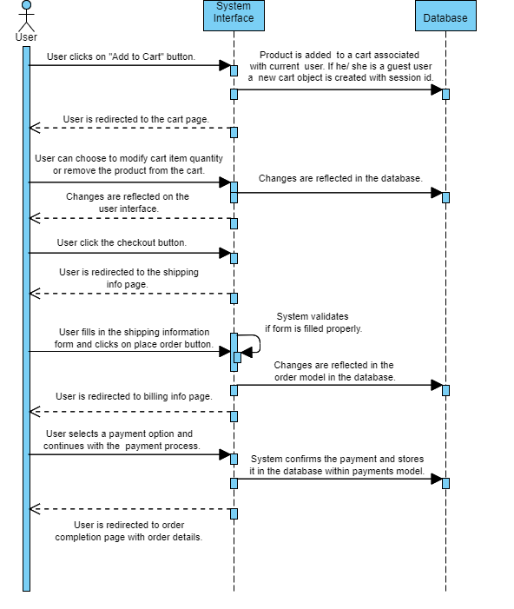

Orders Management:
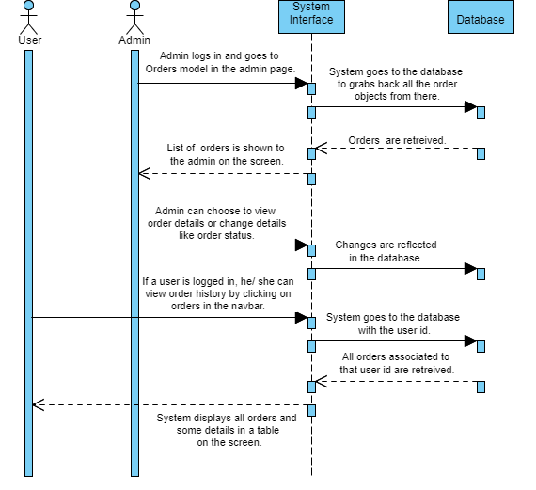

Product Recommendations:

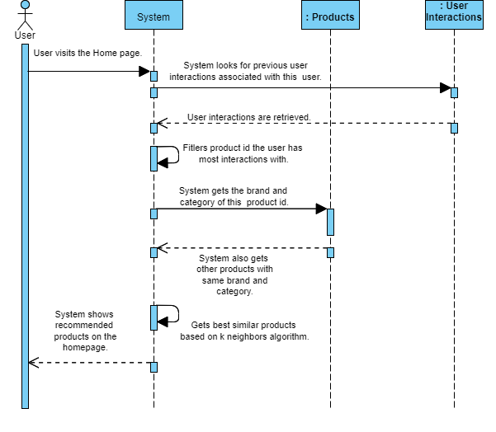

2.7 Object Model/Logical Model: Class Diagram

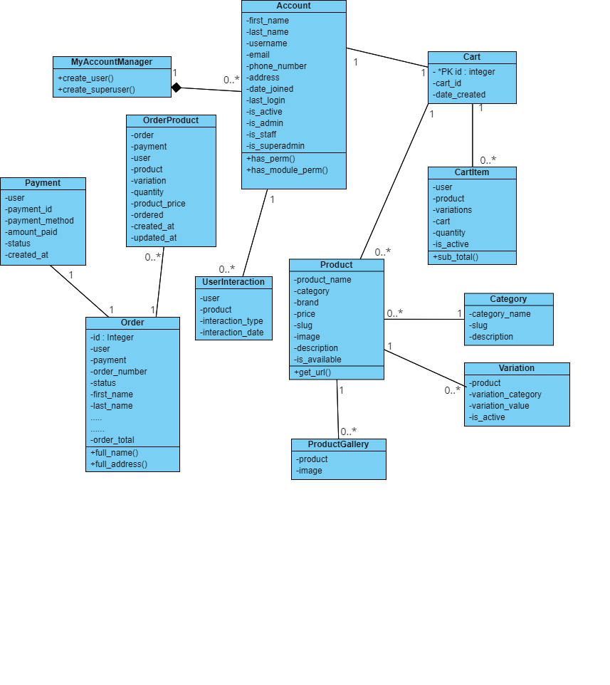

2.8 Database Model (Database Diagram)
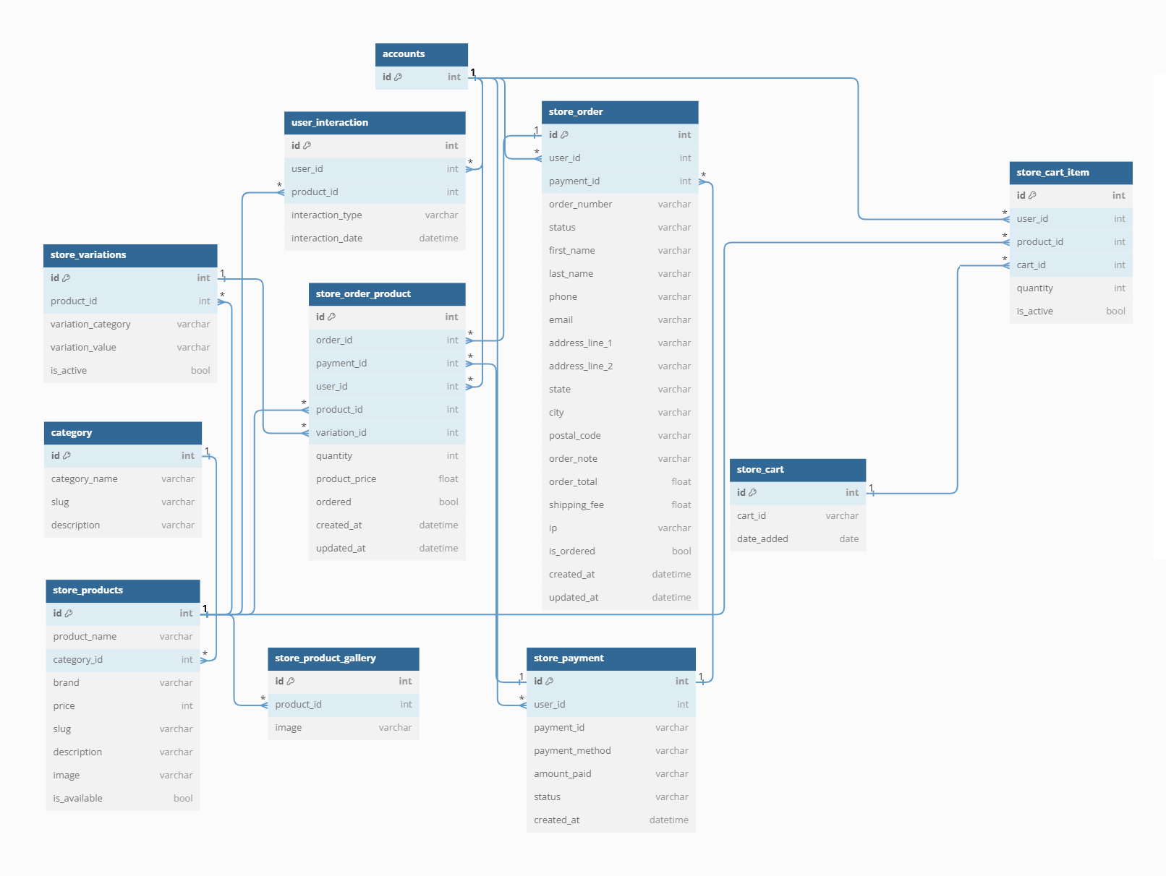

2.9 Graphical User Interfaces
User Registration Interface:
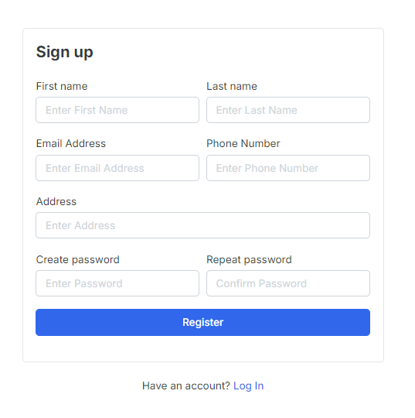

Login Interface:
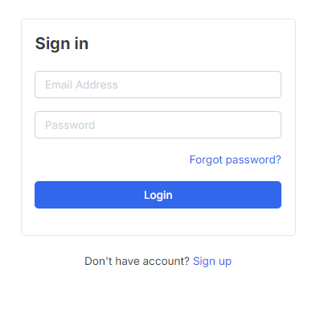

Forgot Password:
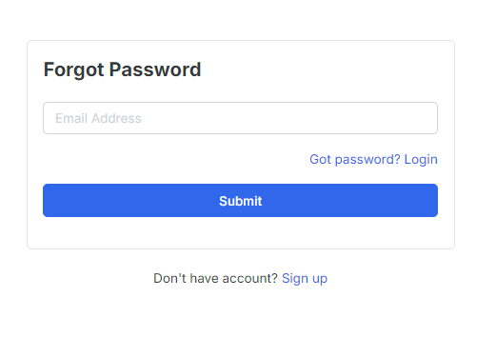

Reset Password Interface:

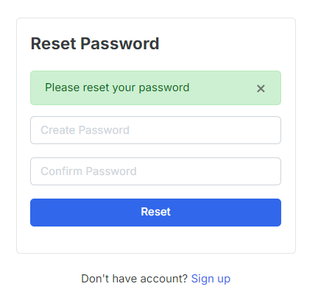

Home Page Interface:

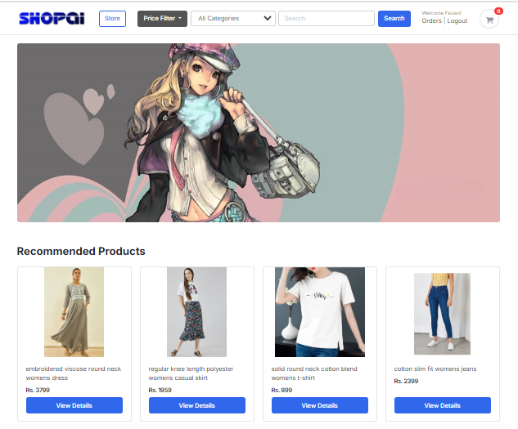

Product Detail Page:

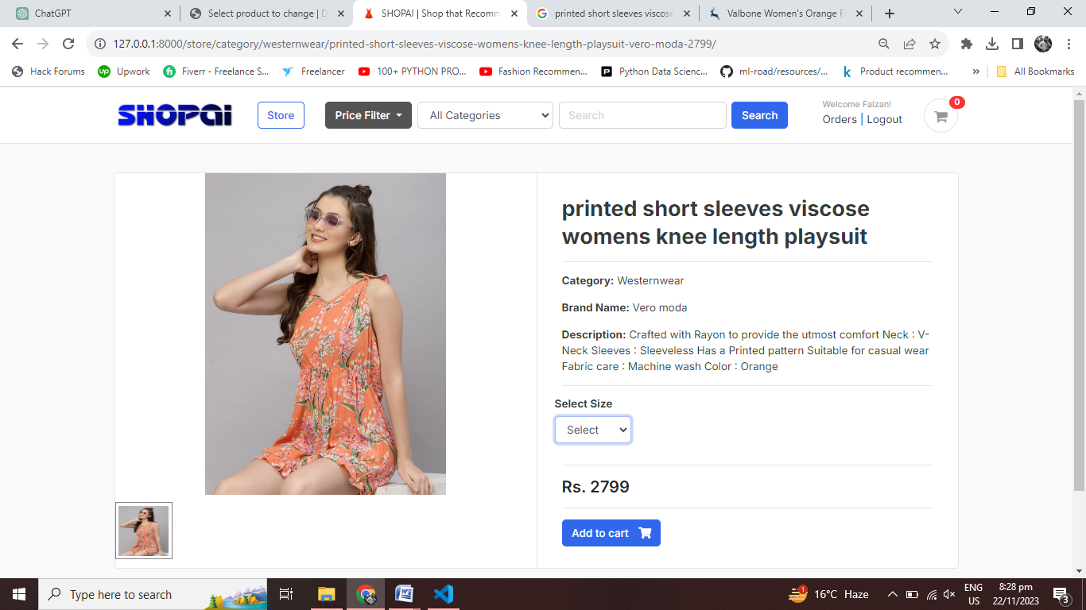

Cart Page for Logged-in User:

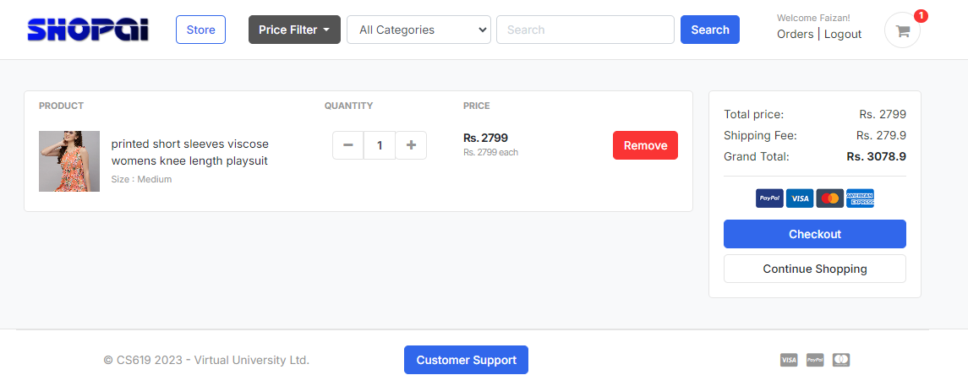

Cart Page for Guest User:

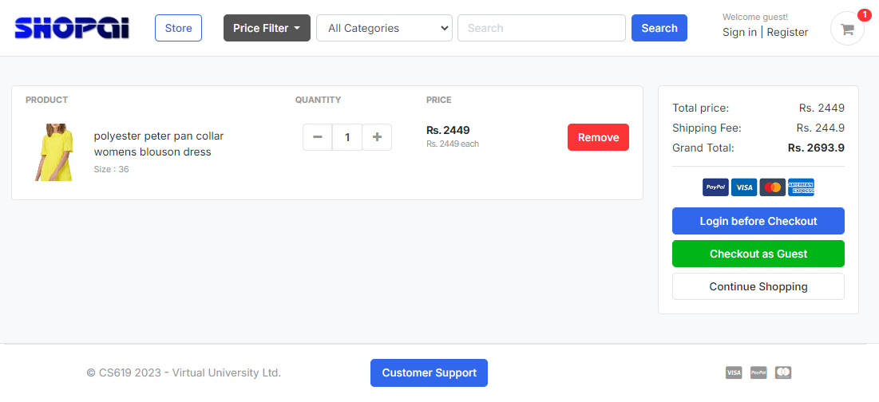

Shipping Info Page:

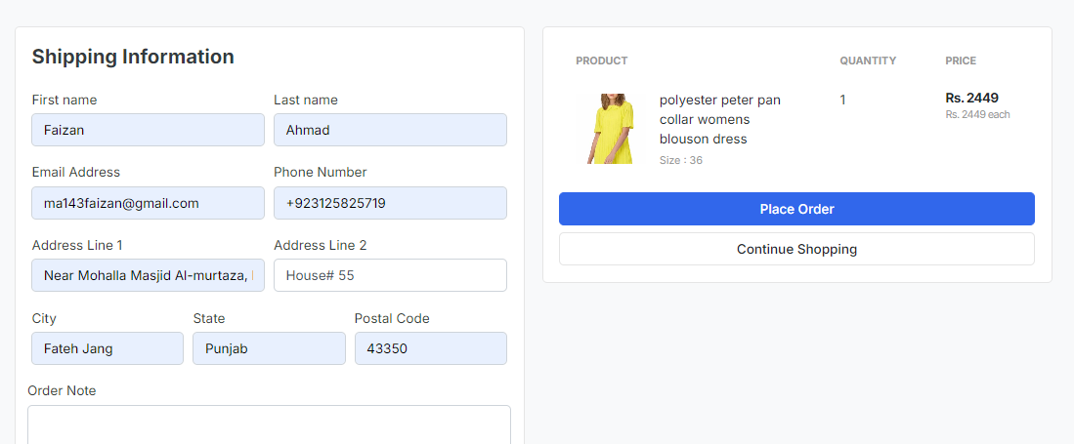

Payment Page:

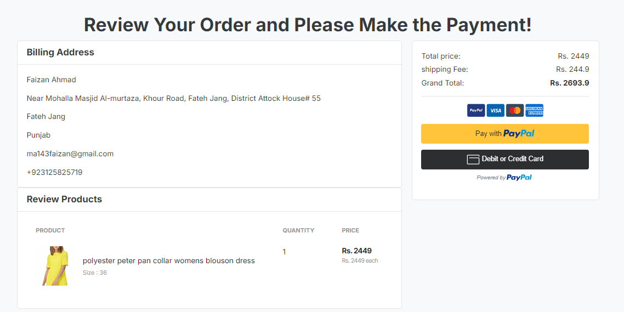

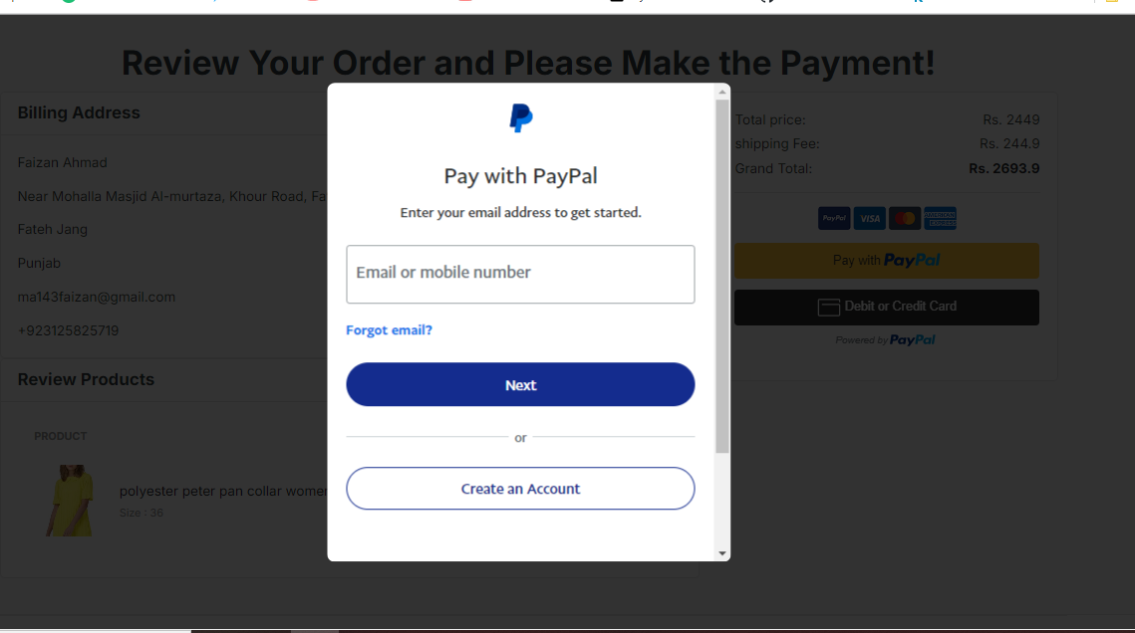

Payment Successful Page:

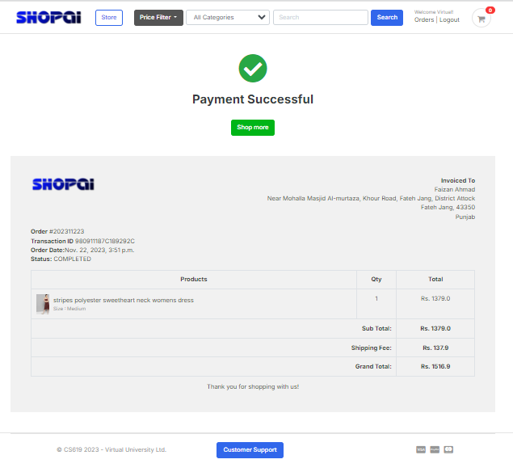

Orders History Page for Logged-in Users:

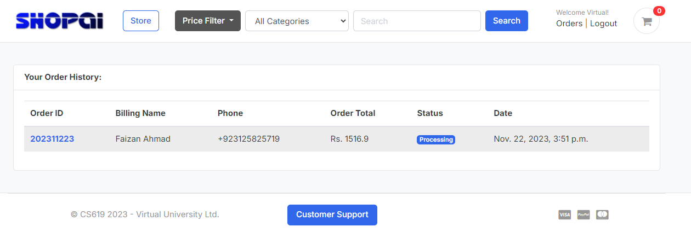

Search and Filtering:

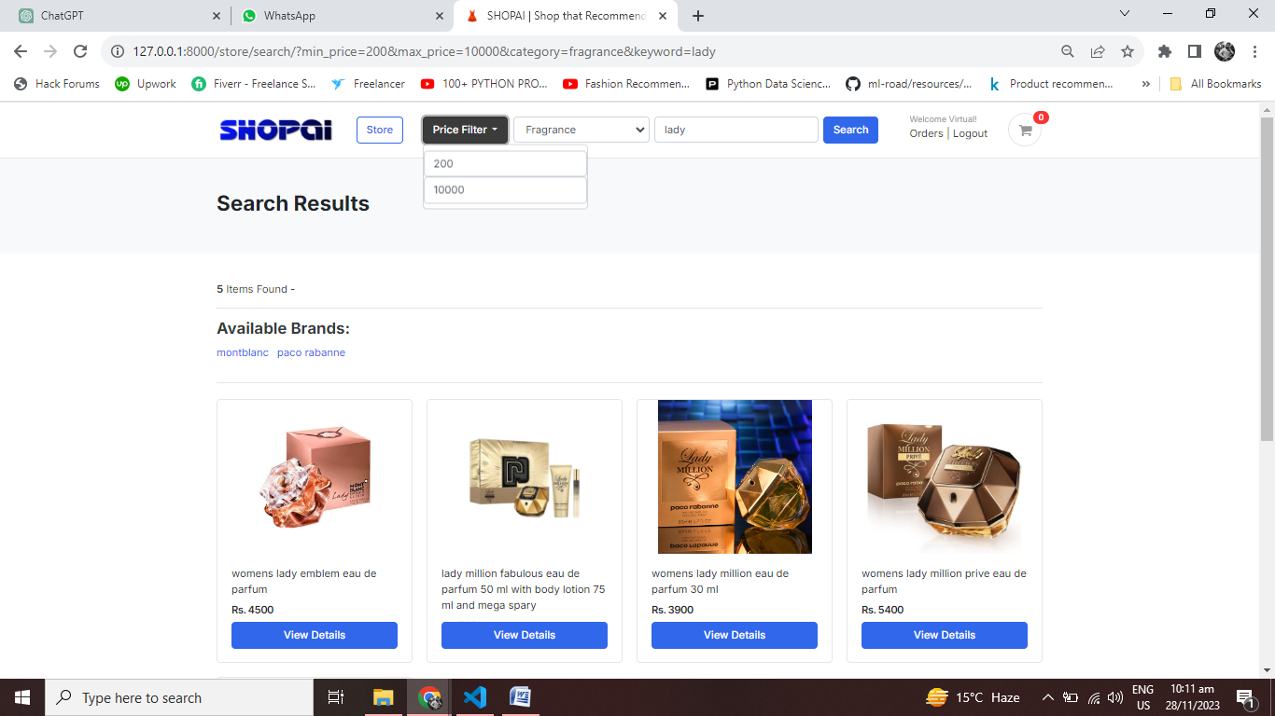

Customer Support Page:
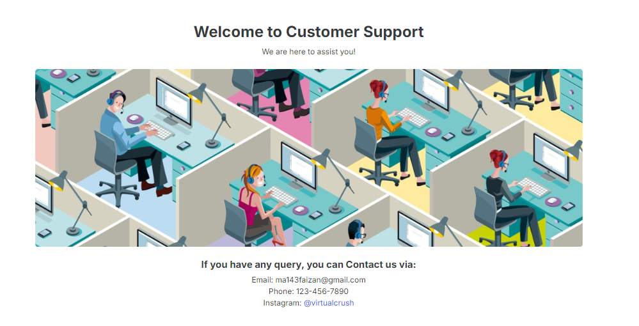

CHAPTER 3
Development

3.1 Development plan (Architecture Diagram)

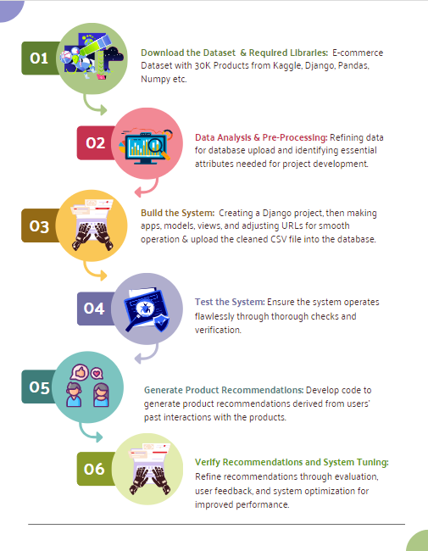

APPENDIX

https://www.kaggle.com/datasets/mukuldeshantri/ecommerce-fashion-dataset

